Name: John Francis  
Date: 3/26/23  
Professor: Shaun Gray

**Network Traffic Management Using SNMP**

**Write a paragraph** (minimum five college-level sentences) below that summarizes what was accomplished in this activity, what you learned by performing it and just as important, how you feel it will benefit you in your academic and professional career. (10 points)

The Simple Network Management Protocol (SNMP) is a network protocol for managing devices on a TCP/IP network. receive alerts/data on the Network management server, SNMP will need to be configured on a device. I was successful in configuring the software and adding NYEDGE1. This allows us to see and verify data on our network management server. This will help me in my academic and professional career by understanding how to set up the network management protocol for monitoring system performance and network data.

Copy and paste the required screenshots from the **Network Traffic Management Using SNMP**activity and answer the questions below.

**Exercise 1 - Task 1, Step 1:** Paste a screenshot after entering the ping 192.168.16.10 command and pressing Enter. Make sure your screenshot contains the required time/date stamp! (10 points)

**Exercise 1 - Task 2, step 12:** Paste a screenshot showing the Setup-PRTG Network Monitor Setup window with the Click Here to Request your free license key (no questions asked) link comment showing. Take the screenshot before selecting next. Make sure your screenshot contains the required time/date stamp! (10 points)

**Exercise 1 - Task 2, Step 20:** Paste a screenshot showing the PRTG welcome screen. Make sure your screenshot contains the required time/date stamp! (10 points)

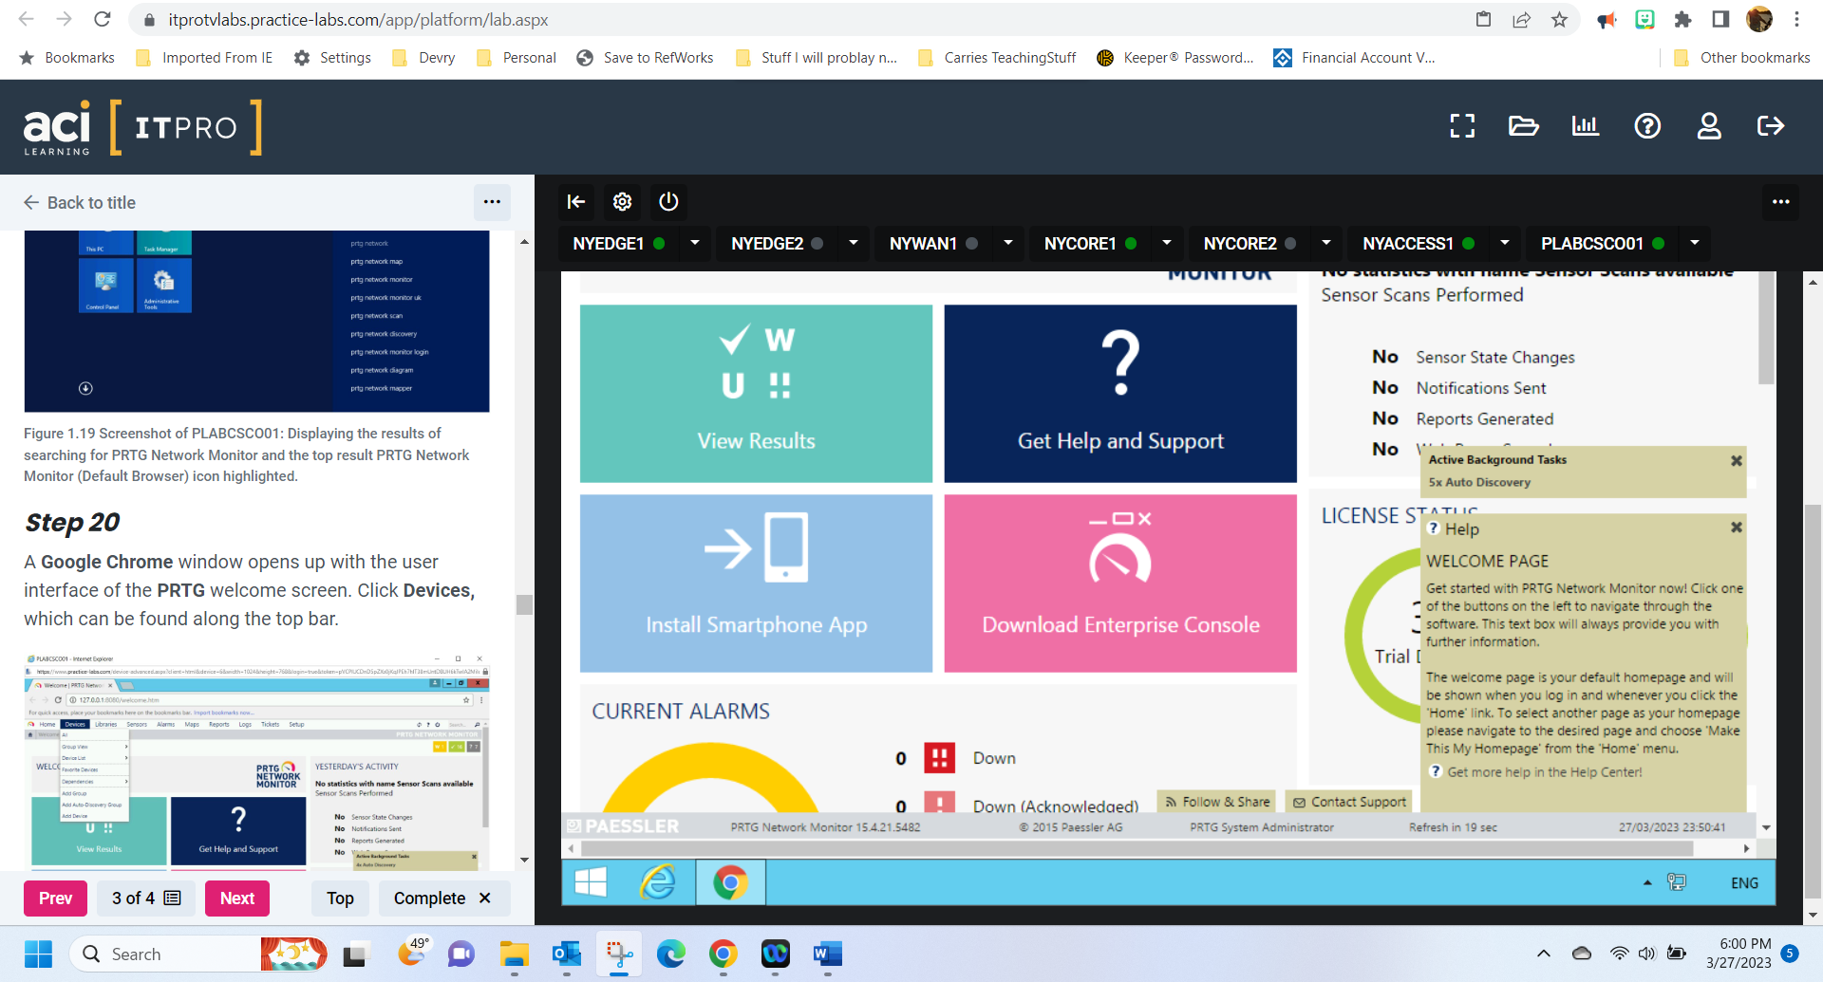

**Exercise 1 - Task 2, Step 25:** Paste a screenshot showing the PLABCSC001 screen displaying the Add Device to Group Network Infrastructure with NYEDGE1 and 192.168.16.1 added. Make sure your screenshot contains the required time/date stamp! (10 points)

**Exercise 1 - Task 2, Step 28:** Paste a screenshot of PLABCSC001 displaying the screen with the sensors created for the NYEDGE1 device. Make sure your screenshot contains the required time/date stamp! (10 points)

**Congratulations! You are done with Module 5 graded practice activities!**